CHITTAGONG UNIVERSITY OF ENGINEERING AND TECHNOLOGY (CUET)
DEPARTMENT OF COMPUTER SCIENCE AND ENGINEERING
CHITTAGONG-4349

(Project/Thesis Proposal)

Application for the Approval of B. Sc. Engineering Thesis/Project
(Computer Science & Engineering)

Date: 11.01.2017
1. Name of the student : A S M Nazrul Islam
Student ID : 1204021
Session : 2015-2016
2. Present Address : Room no- A 508, Bangabandhu Hall, CUET, Chittagong.
3. Name of the Supervisor : Abu Hasnat Mohammad Ashfak Habib.
Designation : Assistant Professor
Department of Computer Science and Engineering (CSE)
Chittagong University of Engineering and Technology.
4. Name of the Department: Computer Science and Engineering
Programme : B. Sc. Engineering
5. Date of First Enrolment
in the Program : March 06, 2013.
6. Tentative Title : To Design and Implement a Smartphone Based Dynamic Fall
Detection System

7. Introduction:
Falls are considered as the second leading cause of accidental or unintentional injury deaths worldwide. A fall is defined as an event which results in a person coming to rest inadvertently on the ground or floor or other lower level [1]. Fall-related injuries may be fatal or non-fatal. For example, in People’s Republic of China, for every death due to fall, there are 4 cases of permanent disability, 13 cases requiring hospitalization for more than 10 days, 24 cases requiring hospitalized for 1-9 days and 690 cases seeking medical care or missing work/school [1]. The largest morbidity occurs in people aged 65 years of older, young adults, aged 15-29 years and children aged 15 years of younger.

Each year around 4, 24,000 individuals [1] die globally from falls. Regions of Western Pacific and South East Asia are accounting for more than two thirds of these deaths. Aside from death, falls are also responsible for over 17 million DALYs (disability-adjusted life yeas) lost [1]. While, nearly 40% of the total DALYs lost due to falls worldwide occurs among children. Around 37.3 million falls are severe enough to require medical attention. One out of five falls causes a serious injury like broken bones or head injury [2, 3]. More than 95% of hip fractures are caused by falling [4]. Falls are also most common cause of traumatic brain injuries [5] and 80% of this occurs in low and middle-income countries.

Individuals from all age group are prone to fall, starting from children to old. And this fall rate is high especially among children, pregnant-women and old men. Though, the risk of fall increases below 6 years and above 60 years gradually. In the year 2004, nearly 47,000 children and young under the age of 20 years died [6] as a result of fall.

Children falls as a result of their evolving developmental stages, innate curiosity of their surroundings and the alarming increasing levels of independence that coincide with more challenging behaviors commonly referred to as “risk factor”. In adequate adult supervision, interacting with poverty, sole parenthood is also considered as risk factor. In Bangladesh also the lead cause of child-injury is fall. The fatal fall injury rate was 2.8/100 000 for children of all ages. Around 770 children are injured each day. Among them 10 are cursed with permanently disability each day [7].

In case of pregnant-women, due to their ongoing physical transformation, they are very prone to sudden seizure and loosing sense. Failure of immediate assistance can affect both mother and child.
Old peoples are much more prone to falls. Each year 2.8 million older people are treated in emergency departments for fall injuries [8]. In United States of America, 20-30% of older people who fall suffer moderate to severe injuries such as bruises, hip fractures or head traumas.
It has been observed that males are more likely to die from a fall, while female suffers more non-fatal falls. Worldwide males consistently sustain higher death rates and DALYs lost.

Financial costs from fall-related injuries are substantial. For people aged 65 years or older, the average health system cost per fall injury in the Republic of Finland and Australia are US$ 3611 and US $ 1049 respectively. Direct medical costs for fall in uries are $ 31 billion annually [9]. Hospital costs account for two-thirds of the total.

Additionally, many people who fell, even not being injured, become afraid of falling. This fear may cause a person to shrink their everyday activities. When a person is less active they became weaker and this increases their chances of falling [10].

So, the considerable risks of falls and the substantial increase in population has stimulated both commercial product and academic research on fall detection and prevention. A typical fall detection system complies of two major parts: the detection component which detects fall and the communication component which communicates with the given contact persons. Evidence from China suggests that the implementation of effective fall prevention would create a net savings over US $ 120 million each year.

8. Background and present state of the problem:
Due to different adverse effects in social, physical, psychological and economical, falls have been an attractive issue to the researchers for the last decade. Fall detection techniques can be generalized into three categories: sensor-based detection, database-based motion type classification and visual-based detection.

In sensor-based detection process, in general external sensor’s value like, accelerometer sensor’s value is used. And when the accelerometer sensor is used most methods are based on thresholds. In [11], Nyan et al. used an accelerometer that has to be settled in the shoulder garment. Kangas et al. in [12] proposed using four thresholds for total sum vector, dynamic sum vector, vertical acceleration and difference between the acceleration’s maximum and minimum values. Other than accelerometer, gyroscope sensor’s value is also used in fall detection. In [13, 14] information of body’s orientation and pressure are also used to detect acceleration based fall detection. Pannurat et al. in [15] offered a commercial off-the-shelf wearable device for fall detection. The most common position for these devices is waist position provided with a ‘panic button’. And most products are powered by a lithium-ion battery and employ embedded sensors to detect falls. CARA architecture [16] proposed to send the data of a wearable accelerometer to an external non-portable gateway which applies a threshold method to detect fall. ZigBee is the wireless technology between the wearable sensors and a central server in the system that is portrayed in [17]. Arduino Fio hardware containing a gyroscope and a accelerometer is used as a compact to detect falls in [18] by sending alarm via Bluetooth to a nearby smartphone.

Though recently, due to availability of multiple embedded sensors and cost shrinking, smartphones have got the full attention and attraction. But, in previous and still external circuit/device is being used to detect falls. Brickhouse [19] consists of a tele-assist base and a portable sensor. In which base device is needed to be installed indoors. So, the signal transmission distance between the base and the sensor is limited and results in severe drawbacks. Like, the monitoring place is fixed and the installment, adjustment and monitoring cost are quite high. Medical Guardian [20] provided an economic fall alarm monitor that has a fixed distance range and works by using nation-wide cellular network but, it has been awarded ‘Gold Award’ for the year 2016 for its customer review.

In case of database based fall detection systems, Ganti et al. in [21] and Karantonis et al. in [22] proposed for storing sensed user behavior data into a database for various activities like, fall down and recognition hereafter. These databases stored with sensed data are very useful. They can also be used for detecting much more activities and for pattern recognition of an individual. Fu et al. in [23], Sixsmith et al. in [24], Miaou et al. in [25] and Jansen et al. [26] proposed for capturing images of people and then detecting visual falls based on image processing techniques.

But in last few years, the number of fall detection apps in smartphones is increasing day by day due to easy availability of smartphones and multiple sensors embedded in them. And these are being developed in various operating systems of smartphones. Like, initial smartphone based fall detection were developed in Symbian OS on Nokia phones [27]. In [28], a Java multiplatform software architecture, using external architecture was employed in both a Symbian phone (Nokia 5800) and Android smartphones (Samsung Galaxy, HTC hero) to detect falls.

In android platform, a vast literature on fall detection systems has been generated. The general principles of fall detection for elderly have been summarized by Yu [29] and Noury [30] while different classifications of fall assessment techniques have been presented by Pannurat et al. [15], Hedge et al. [31], Noury et al. [30, 32], Hijaz et al. [33]. However, smartphone based fall detection and prevention architectures are specifically revised in a great detail by Habib et al. in [34].

But, in the prevailing systems there exists some obstacles like; the smartphone’s position is kept fixed. So, a fixed threshold had to use. But it is inconvenient in real life. Because, an individual can keep his/her smartphone in any place in accordance with his/her comfort. So, the existing techniques are not dynamic. Hence, my approach will be to eradicate this limitation.

9. Aims with specific objectives and possible outcomes:

The aims of this project are:
- To design and implement a novel smartphone-based fall detection technique that uses multiple numbers of inbuilt smartphone sensors.
- To make the technique dynamic so that it can automatically detect the position of the smartphone and select the appropriate threshold values accordingly.
- To make the technique false alarm exempt by fusing multiple sensor’s value, so that it can avert the limitations of the previous works.
- To make the technique robust and efficient by placing instant communication right after the occurrence of fall. Hence, resulting in restoring life.

So, the objective of this project is to design a reliable and dynamic fall detection system, which has low fault tolerance and has higher efficiency.
As accelerometers usually provide the acceleration readings in x, y and z directions, so, accelerations in these directions are termed as respectively A_{X} , A_{Y} and A_{Z}. And vector |A_{T}| represents the amplitude of total acceleration of the smartphone’s body.
|A_{T}| = √ (|A_{X}|² +|A_{Y}|² + |A_{Z}|²)

And |A_{V}| is the amplitude of acceleration in the absolute vertical direction. Which is calculated by using θ_{X} , θ_{Y} and θ_{Z} (obtained by smartphone’s orientation sensor and respectively denoted as yaw, pitch and roll ).
|A_{V}| = |A_{X} sin θ_{Z} + A_{Y} sin θ_{Y} + A_{Z} cos θ_{Y} cos θ_{Z} | 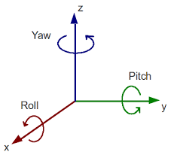

10. Outline of Methodology/Experimental Design: 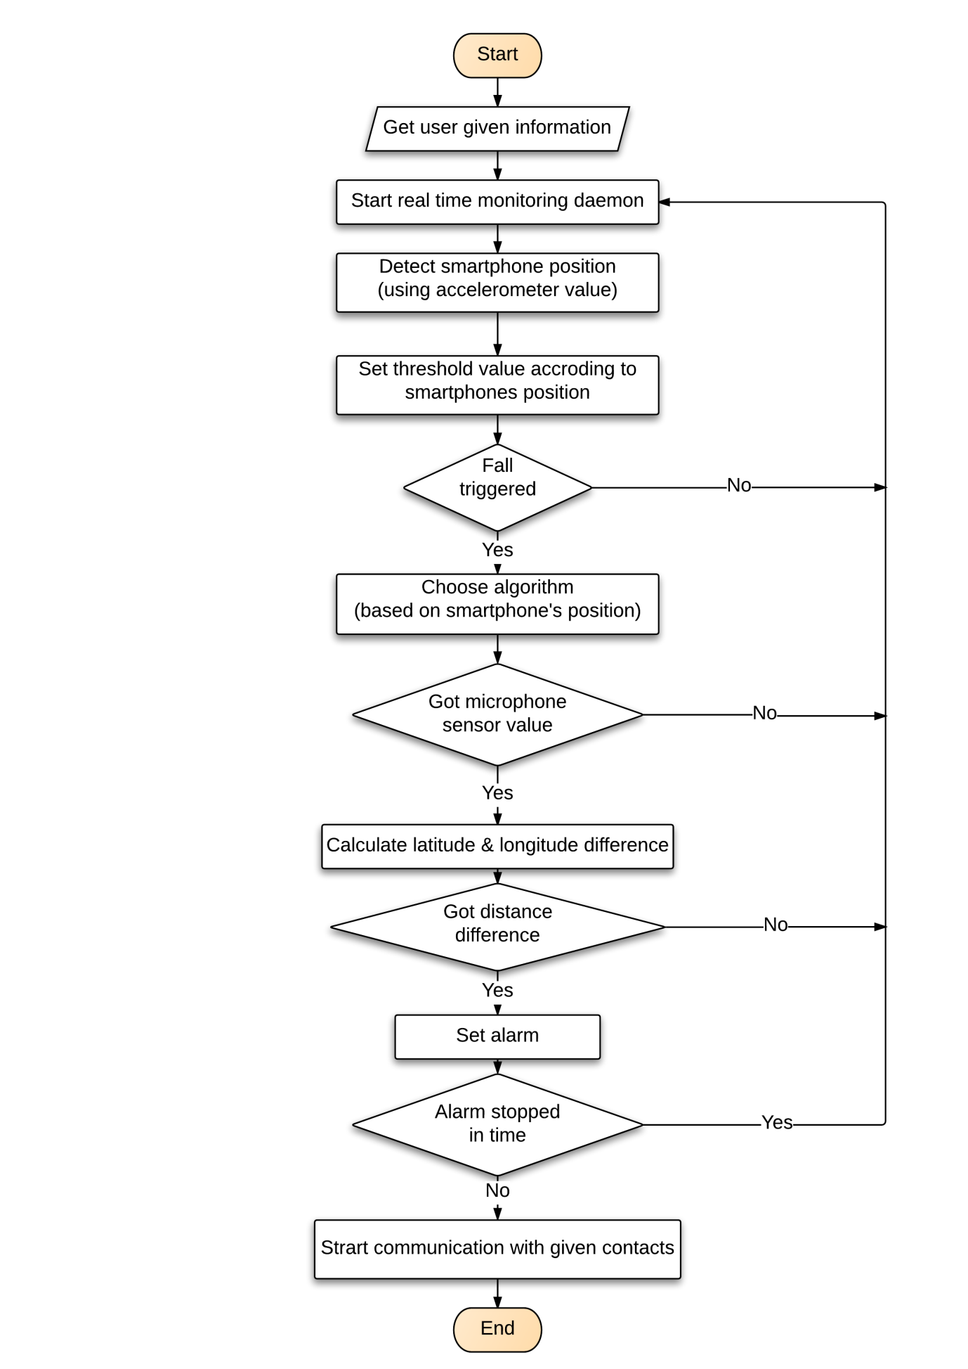 Fig no 01: The system flow diagram of the proposed fall detection system.

The whole architecture of the system is consists of three main modules.
- Data collection module
- Data analysis and implementation module
- Sensor fusion module
- Communication module

10.1 Data collection module
10.1.1 Getting user information
After getting started, the system will ask the user for emergency contact numbers as his/her preferences for future communication.
10.1.2 Working as daemon
In this step the system will work as a service in background of the smartphone. There, it will collect the values of accelerometer.

10.2 Data analysis and implementation module
10.2.1 Detecting smartphone’s position
The first step of data analysis will be to determine the smartphone’s position. In this step, the values of the accelerometer’s x, y and z axis direction will be analyzed to determine the smartphone’s position, whether it is in shirt’s pocket or in pants pocket or in waist belt. As the placement of smartphone, in different position is different.
10.2.2 Set threshold value
In this step, the system will set the threshold value for the position detected in the previous step.
10.2.3 Detecting fall
If the accelerometer values collected in real time satisfies certain preset condition like, the difference of |A_{T}| within a triggering time space T_{tt} exceeds triggering threshold Th _{tt} and also the difference of |A_{v}| within a triggering time space T_{tv} exceeds triggering threshold Th _{tv,} the system control flows to the next step i.e. choosing algorithm.
10.2.4 Choosing Algorithm
After getting trigged, the system checks if, difference between the maximum and minimum value of |A_{T}| within a checking time space T_{ct} following T_{tt} is less than another threshold Th_{ct} and also the difference between the maximum and minimum value of |A_{v}| within a checking time space T_{cv} following T_{tv} is less than another threshold Th_{cv} ,it is considered that a fall might have happened.

10.3 Sensor fusion module
10.3.1 Obtaining microphone sensor value
In this step, the system will check whether the microphone sensor has caught a value. Because, the fall of an individual generates a specific kind of sound. So, if, a value is obtained and it is close or in the range of the pre-defined value, the system control then flows to the next step.
10.3.2 Calculating location difference
Every location in earth has its own geo co-ordinates, which are provided by GPS. In this step, the difference between the latitude and longitude of the triggering position and the position where microphone sensor value was obtained will be calculated. Because, when a person falls, he/she does not fall in the exact same place where he/she was standing. So, if a change of position is found out, it considered that a fall has happened.
10.3.3 Checking alarm dismissal
If, the previous conditions are fulfilled an alarm is set immediately for a fixed amount of time. If, the user stops the alarm, it is noted as false positive. And the system returns to its daemon condition i.e. working as a background service. And if the alarm is not dismissed, it is considered as a fall has actually happened.
10.4 Communication module
In this module, the system instantaneously communicates with the pre-set contacts given by the user. The communication can be done in several ways. It can be done by sending emergency short-message or by sending email or by making an emergency call with the fallen location of the victim.

11. Resources Required Completing the Work:
The required resources for completing the work are:
- PC (Personal Computer)
- A Smartphone
- An IDE (Android Studio)

12. Cost Estimation:
The estimated cost to implement the proposed system is in the following:
- Cost materials:
PC (Personal Computer) = Tk. 40,000/=
- Typing, Drafting, Binding:
Internet browsing = Tk. 2,000/=
Paper = Tk. 300/=
Printing = Tk. 500/=
Drafting = Tk. 200/=
Binding = Tk. 200/=
- Miscellaneous:
Miscellaneous = Tk. 1,000/=

Total = Tk. 44,200/=

13. References:
[1] World Health Organization (WHO)’s official site [Online], Available at http://www.who.int/mediacentre/factsheets/fs344/en/ Accessed 7 January 2017.
[2] Alexander BH, Rivara FP, Wolf ME, “The cost and frequency of hospitalization for fall–related injuries in older adults”, in proc. American Journal of Public Health, 1992; 82(7): pp.1020–3.
[3] Sterling DA, O'Connor JA, Bonadies J. “Geriatric falls: injury severity is high and disproportionate to mechanism”, in proc. Journal of Trauma–Injury, Infection and Critical Care, 2001; vol 50(1): pp.116–9.
[4] Hayes WC, Myers ER, Morris JN, Gerhart TN, Yett HS, Lipsitz LA. “Impact near the hip dominates fracture risk in elderly nursing home residents who fall”, in proc. Calcified Tissue International, 1993;vol 52: pp.192-198.
[5] Jager TE, Weiss HB, Coben JH, Pepe PE. “Traumatic brain injuries evaluated in U.S. emergency departments, 1992–1994”, in proc. Academic Emergency Medicine 2000&359; vol 7(2): pp.134–40.
[6] World report on child injury prevention, Geneva: World Health Organization (WHO), ISBN 978 92 4 156357 4, 2008.
[7] Bangladesh Health and Injury Survey Report on Children, Directorate General of Health Services, Ministry of Health and Family Welfare, Government of the People's Republic of Bangladesh, Published: January 2005, ISBN 92-806-3855-6.
[8] Centers for Disease Control and Prevention, National Center for Injury Prevention and Control [Online], Available at Web–based Injury Statistics Query and Reporting System (WISQARS) Accessed January 09, 2017.
[9] Burns EB, Stevens JA, Lee RL. “The direct costs of fatal and non-fatal falls among older adults—United States”, in proc. Journal of Safety Research, 2016:58.
[10] Vellas BJ, Wayne SJ, Romero LJ, Baumgartner RN, Garry PJ. “Fear of falling and restriction of mobility in elderly fallers”, Age and Ageing 1997; vol 26: pp.189–193.
[11] Nyan MN, Tay FE, Manimaran M, Seah KH, “Garmentbased detection of falls and activities of daily living using 3-axis MEMS accelerometer”, in proc. Journal of Physics Conference Series , 2006,vol 34: pp.1059–1067
[12] Kangas M, Konttila A, Lindgren P, Winblad I, Jamsa T, “Comparison of low-complexity fall detection algorithms for body attached accelerometers”,in proc. Gait Posture , 2008,vol 28(2): pp.285–291
[13] Brown G, “An accelerometer based fall detector: development, experimentation, and analysis”, SUPERB internship report, University of California, Berkeley, 2005.
[14] Hwang JY, Kang JM, Jang YW, Kim HC , “Development of novel algorithm and real-time monitoring ambulatory system using Bluetooth module for fall detection in the elderly.”, In: Proceedings of 26th annual international conference of the engineering in medicine and biology society, IEEE-EMBS 2004.
[15] Pannurat, N.; Thiemjarus, S.; Nantajeewarawat, E. “Automatic Fall Monitoring: A Review. Sensors”, 2014, 14, pp. 12900–12936.
[16] Yuan, B.; Herbert, J. “Non-Intrusive Movement Detection in Cara Pervasive Healthcare Application”, In Proceedings of the 2011 International Conference on Wireless Networks, (WORLDCOMP), Las Vegas, NV, USA, 18–21 July 2011; pp. 360–366.
[17] Honglun,H.; Meimei, H.; Minghui, W. “Sensor-Based Wireless Wearable Systems for Healthcare and Falls Monitoring”, Int. J. Smart Sens. Intell. Syst. 2013, 6, pp.2200–2216.
[18] Shuo, C. “Fall Detection System Using Arduino Fio”, In Proceedings of the IRC Conference on Science, Engineering and Technology, Singapore, 13 May 2015.
[19] Available at http://www.brickhousealert.com/personal-emergency-medicalalarm.htm [Online] Accessed 8 January, 2017.
[20] Available at https://www.medicalguardian.com/product/home-guardian [Online] Accessed 8 January, 2017.
[21] Ganti RK, Jayachandran P, Abdelzaher TF, Stankovic JA, “SATIRE: a software architecture for smart AtTIRE”, In: Proceedings of the 4th international conference on mobile systems, applications and services, MobiSys, 2006.
[22] Karantonis DM, Narayanan MR, Mathie M, Lovell NH, Celler BG, “Implementation of a real-time human movement classiﬁer using a triaxial accelerometer for ambulatory monitoring”, in proc. IEEE Trans Inf Technol Biomed, 2006, 10(1): pp.156–167
[23] Fu Z, Culurciello E, Lichtsteiner P, Delbruck T , “Fall detection using an address-event temporal contrast vision sensor:, In: Proceedings of IEEE international symposium on circuits and systems, ISCAS, 2008.
[24] Sixsmith A, Johnson N., “A smart sensor to detect the falls of the elderly”, in proc. Pervasive Comput, 2004, vol 3(2): pp.42–47.
[25] Miaou S, Sung P, Huang C., “A customized human fall detection system using omni-camera images and personal information”, In: Proceedings of 1st distributed diagnosis and home healthcare conference, 2006.
[26] Jansen B, Deklerck R., “Context aware inactivity recognition for visual fall detection”, In: Proceedings of pervasive health conference and workshops, 2006.
[27] Zhao, Z.; Chen, Y.; Wang, S.; Chen, Z. “FallAlarm: Smart Phone Based Fall Detecting and Positioning System”, In Proceedings of the 9th International Conference on Mobile Web Information Systems (MobiWIS), Niagara Falls, ON, Canada, 27–29 August 2012; pp. 617–624.
[28] Laguna, M.A.; Finat, J. “Remote Monitoring and Fall Detection: Multiplatform Java Based Mobile Applications”, In Proceedings of the III International Workshop of Ambient Assisted (Living IWAAL 2011), Torremolinos-Málaga, Spain, 8–10 June 2011; pp. 1–8.
[29] Yu, X. “Approaches and Principles of Fall Detection for Elderly and Patient”, In Proceedings of the 10th International Conference on E-Health Networking, Applications and Services (HealthCom 2008), Singapore, 7–9 July 2008; pp. 42–47.
[30] Noury, N.; Fleury, A.; Rumeau, P.; Bourke, A.; Laighin, G.; Rialle, V.; Lundy, J. “Fall Detection-Principles and Methods”, In Proceedings of the 29th Annual International Conference of the IEEE Engineering in Medicine and Biology Society (EMBS 2007), Lyon, France, 22–26 August 2007; pp. 1663–1666.
[31] Hegde, R.; Sudarshan, B.; Kumar, S.; Hariprasad, S.; Satyanarayana, B. “Technical Advances in Fall Detection System—A Review. Int. J. Comput. Sci. Mob. Comput. 2013, 2, 152–160.
[32] Noury, N.; Rumeau, P.; Bourke, A.; ÓLaighin, G.; Lundy, J. “A Proposal for the Classification and Evaluation of Fall Detectors”, IRBM 2008, 29, pp.340–349.
[33] Hijaz,F.;Afzal,N.;Ahmad,T.;Hasan,O. “Survey of Fall Detection and Daily Activity Monitoring Techniques”, In Proceedings of the 2010 International Conference on Information and Emerging Technologies (ICIET), Pakistan, 14–16 June 2010; pp. 1–6.
[34] Habib, M.A.; Mohktar, M.S.; Kamaruzzaman, S.B.; Lim, K.S.; Pin, T.M.; Ibrahim, F. “Smartphone-Based Solutions for Fall Detection and Prevention: Challenges and Open Issues’, Sensors 2014, 14, pp.7181–7208.

14. CSE Undergraduate Studies (CUGS) Committee reference:

Meeting No.: Resolution No.: Date:

15. Number of Under-Graduate Student(s) working with the Supervisor at Present:

___________________
Signature of the student

______________________
Signature of the supervisor

_________________________________
Signature of the Head of the Department

